Open MathType window, write the mathematical expression

Click on the preference tab and select the top most option “Cut and Copy Preference”
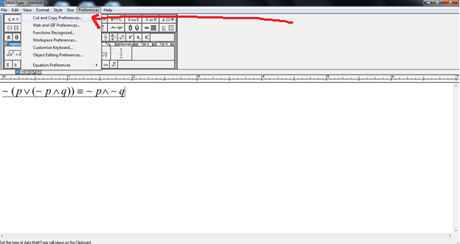
A pop up window will apear as shown below:
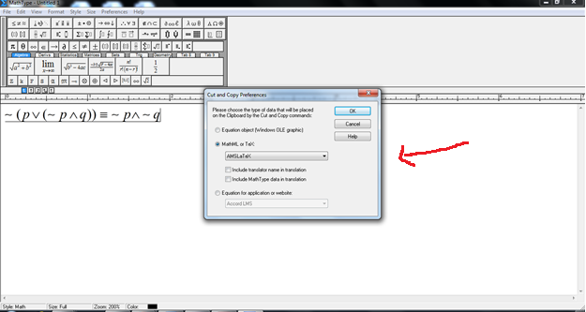

Select “AMSLaTeX” and uncheck all check boxes below, click ok
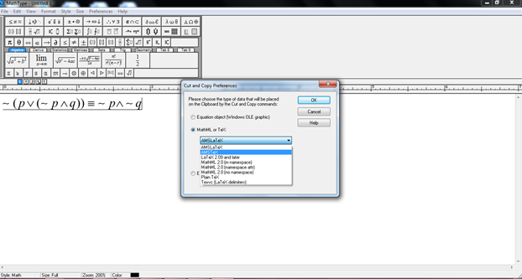

Now select the equation(s) by CTRL+A and then copy by CTRL +C
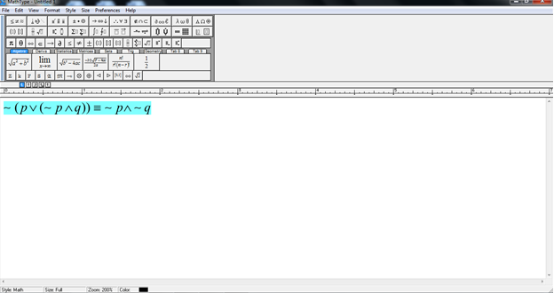
Open GDB reply window 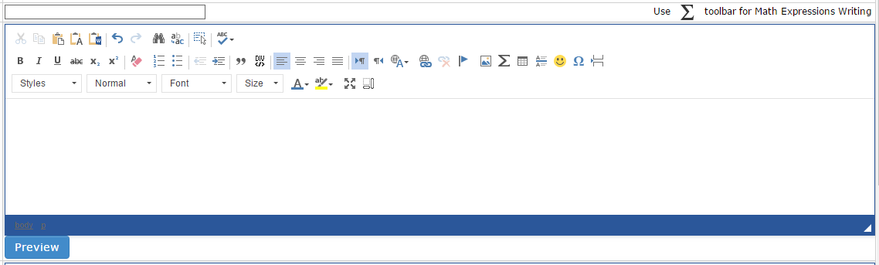
Click on Summation Tab
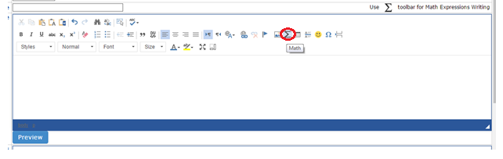
A pop up window will appear as mentioned below:
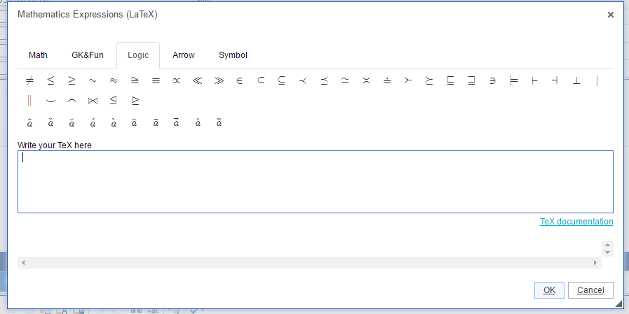
Paste the copied expression in the window and click ok

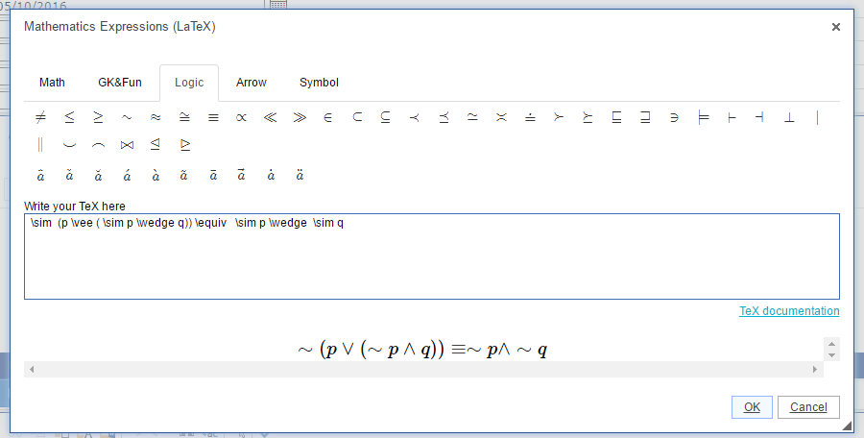

Check the preview and post your reply

